**Mini Festival of German Cinema and Culture of the Weimar Republic**

In 1932 the cinema Le Palace, in Flers-lez-Lille, presented its first talking film. It was "Atlantis" by G.W. Pabst, shot in the Sahara and mounted in Babelsberg. The film had three versions: in German: Die Herrin von Atlantis, in English: The mistress of Atlantis, and in French!

To commemorate the 90th anniversary of the arrival of talking cinema in Flers (Villeneuve d'Ascq), Antoine Tillard of the cinema Le Méliès, Gérard Collet of the Association for Friendship between Villeneuve d'Ascq and Leverkusen (AAVAL) and Sylvain Calonne of the Historical Society of Villeneuve d'Ascq (SHVA) have joined forces to create a Mini-festival of German cinema of the 1920s, the time of the Weimar Republic. Between March 23 and April 5, two emblematic films of German cinema, "Metropolis", silent film (2h30) by Fritz Lang (1927) and "The Blue Angel", a film by J. von Sternberg (1930) were screened at the Méliès.

And two lectures on the interwar period were given at the Castle of Flers. That of Mr. Mathias Steinle on cinema under the Weimar Republic: "The golden age of German cinema: how German cinema, at the time, competed with Hollywood!". Mathias Steinle is a lecturer in audiovisual cinema at the Sorbonne Nouvelle University (Paris) and a member of the Institut de Recherche sur le Cinéma et l'Audiovisuel (IRCAV).

The speaker showed the diversity of productions of German filmmakers between 1919 and 1939. German filmmakers and artists of this Golden Age strongly influenced American Hollywood cinema. Film excerpts were commented and analyzed.

With the advent of talking cinema, German directors had to solve the problem of films shot in several languages. The speaker showed the creativity of Babelsberg's filmmakers who developed cinematic processes that they used in Hollywood when they found refuge in the United States to escape the racist policies of Nazi Germany.

The other lecture by Mr Didier Franc fort: "Germany, 1920s, from defeat to the Crisis to the 'Roaring Twenties' will show the incredible abundance and diversity of German cultural life during the Weimar Republic. Didier Francfort is Professor of Contemporary History and Deputy Director of the Centre for Research on European Cultures and Literatures at the University of Lorraine. He presented a fabulous panorama of German culture forming a kaleidoscope of cultural markers. The speaker presented from a selection of 250 testimonies of this cultural richness significant examples in the field of arts, music, songs, jazz, morals, modernity and inventions that announce the contemporary intellectual and social heritage.

These cultural events are presented as part of the European Erasmus + project "Urban Spaces in the Interwar Period" bringing together eight European cities around the twin historical societies of Leverkusen (Opladener Geschichtsverein von 1979 e.V.) and Villeneuve d'Ascq. This project, set up by the Leverkusen Historical Society (OGV), aims to educate and publicize the history of the twin cities of Leverkusen in the interwar period across Europe.

The European project Urban Spaces studies cultural history in all its forms from 1918 to 1939 in Europe. Eight cities from six European countries joined forces to show the similarities and differences in their political, social, economic and cultural histories during the interwar period.

The aim of the project is to develop cultural cooperation between the eight twin cities, share new knowledge and develop products such as film clips, publications, exhibitions and events that will be used for promotional and educational purposes.

Bracknell (England), Villeneuve d'Ascq (France), Racibórz (Poland), Oulu (Finland), Ljubljana (Slovenia), Jülich (Germany), Leverkusen (Germany), Schwedt/Oder (Germany) are partners of the European project: "Urban Spaces in the Interwar Period in Europe"

The project is co-funded by our sponsors, the European Union and Erasmus+.

**Lundi 4 avril Cinéma Méliès** : projection du film **« L’Ange bleu »** de Josef von Sternberg (1930)

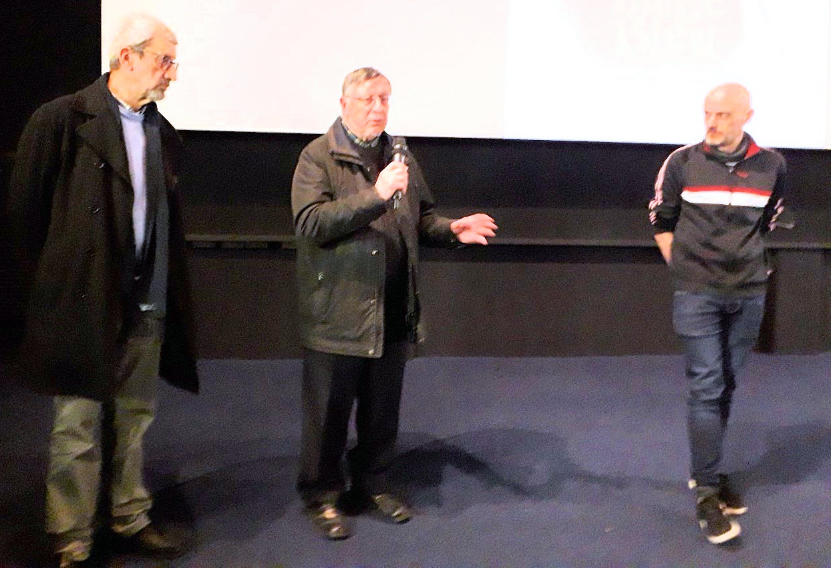

Bracknell (Angleterre), Villeneuve d'Ascq (France), Racibórz (Pologne), Oulu (Finlande), Ljubljana (Slovénie), Jülich (Allemagne), Leverkusen (Allemagne), Schwedt/Oder (Allemagne) sont partenaires du projet européen :

« Espaces Urbains dans l’Entre-deux-guerres en Europe»

Le projet est cofinancé par nos sponsors, l’Union européenne et Erasmus+.

